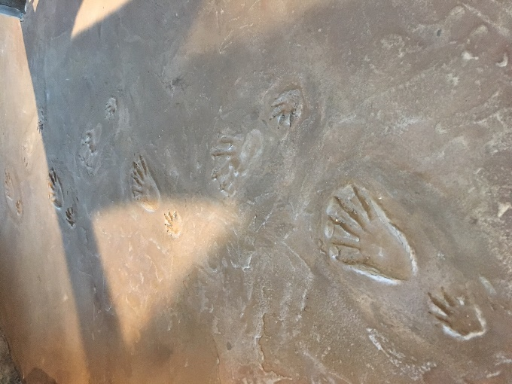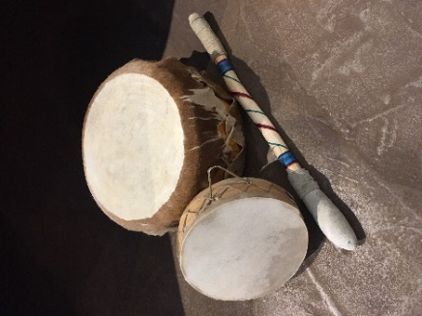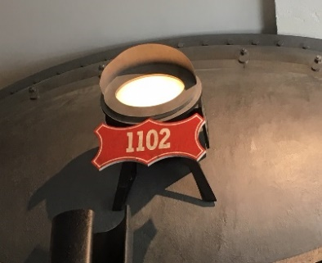

I think you can, I think you can, I think you can find these clues! Stop by the Native American home to play some tunes. When tracking these items, look down to make sure you are not tracking something else.

# **History Museum I-Spy**

Can you find all of these hidden items in the museum?

# **History Museum I-Spy**

Can you find all of these hidden items in the museum?



I think you can, I think you can, I think you can find these clues! Stop by the Native American home to play some tunes. When tracking these items, look down to make sure you are not tracking something else.

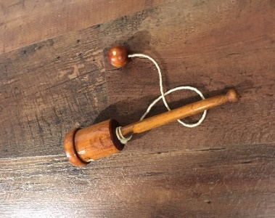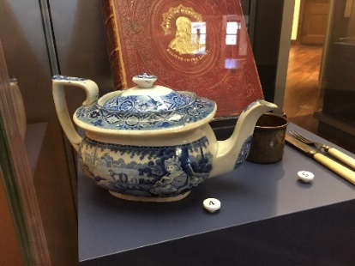

After your long train journey, you might relax with a cup of tea. Then, take a look around the General Store. You may just find a game that you adore.

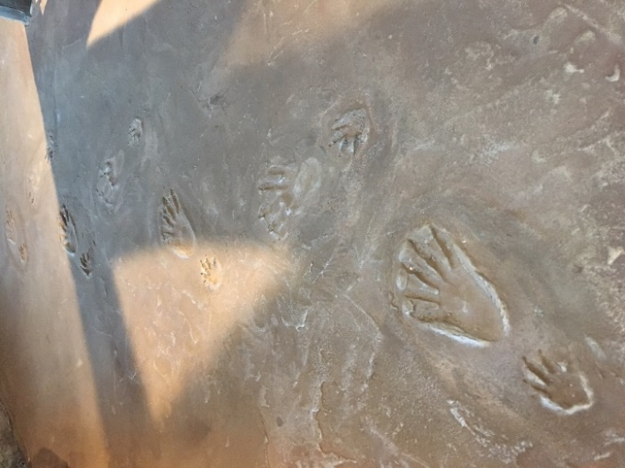



After your long train journey, you might relax with a cup of tea. Then, take a look around the General Store. You may just find a game that you adore.



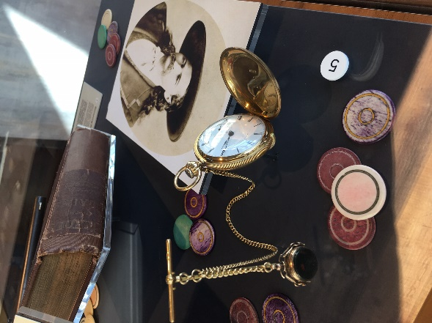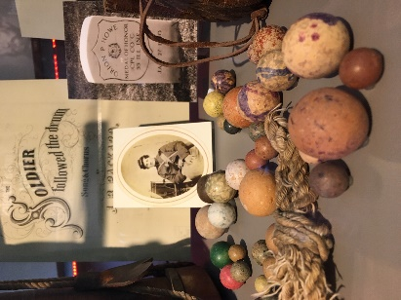

Knuckles on the ground, this toy is round. It is too bad we are not playing for keeps!

You’ll be like this sharpshooter if you keep your eyes on the prize. Can you find the time to find it?

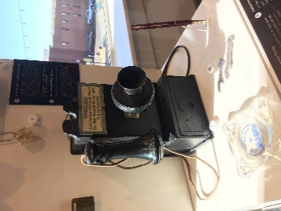

On your Route 66 road trip, you may need to use this phone so you can call home. After you find these last things, hop on down to say goodbye!



On your Route 66 road trip, you may need to use this phone so you can call home. After you find these last things, hop on down to say goodbye!



Knuckles on the ground, this toy is round. It is too bad we are not playing for keeps!

You’ll be like this sharpshooter if you keep your eyes on the prize. Can you find the time to find it?